MARKETING FUNNEL BASICS, METRICS & RATIOS

- Draw a simple marketing funnel for an app you use daily (like Zomato or Instagram) and label each stage (Awareness, Interest, Consideration, Conversion, Loyalty) with a real example action a user might take at that stage.

Marketing Funnel (Zomato)

- Awareness : User sees a Zomato ad on Instagram or YouTube.

- Interest : User downloads the Zomato app and looks at different restaurants and cuisines.

- Consideration : User checks restaurant reviews, ratings, and compares food prices.

- Conversio : User selects food, adds to cart, and makes the payment on Zomato.

5. Loyalty : User keeps ordering regularly, uses Zomato Gold, and looks for special offers.

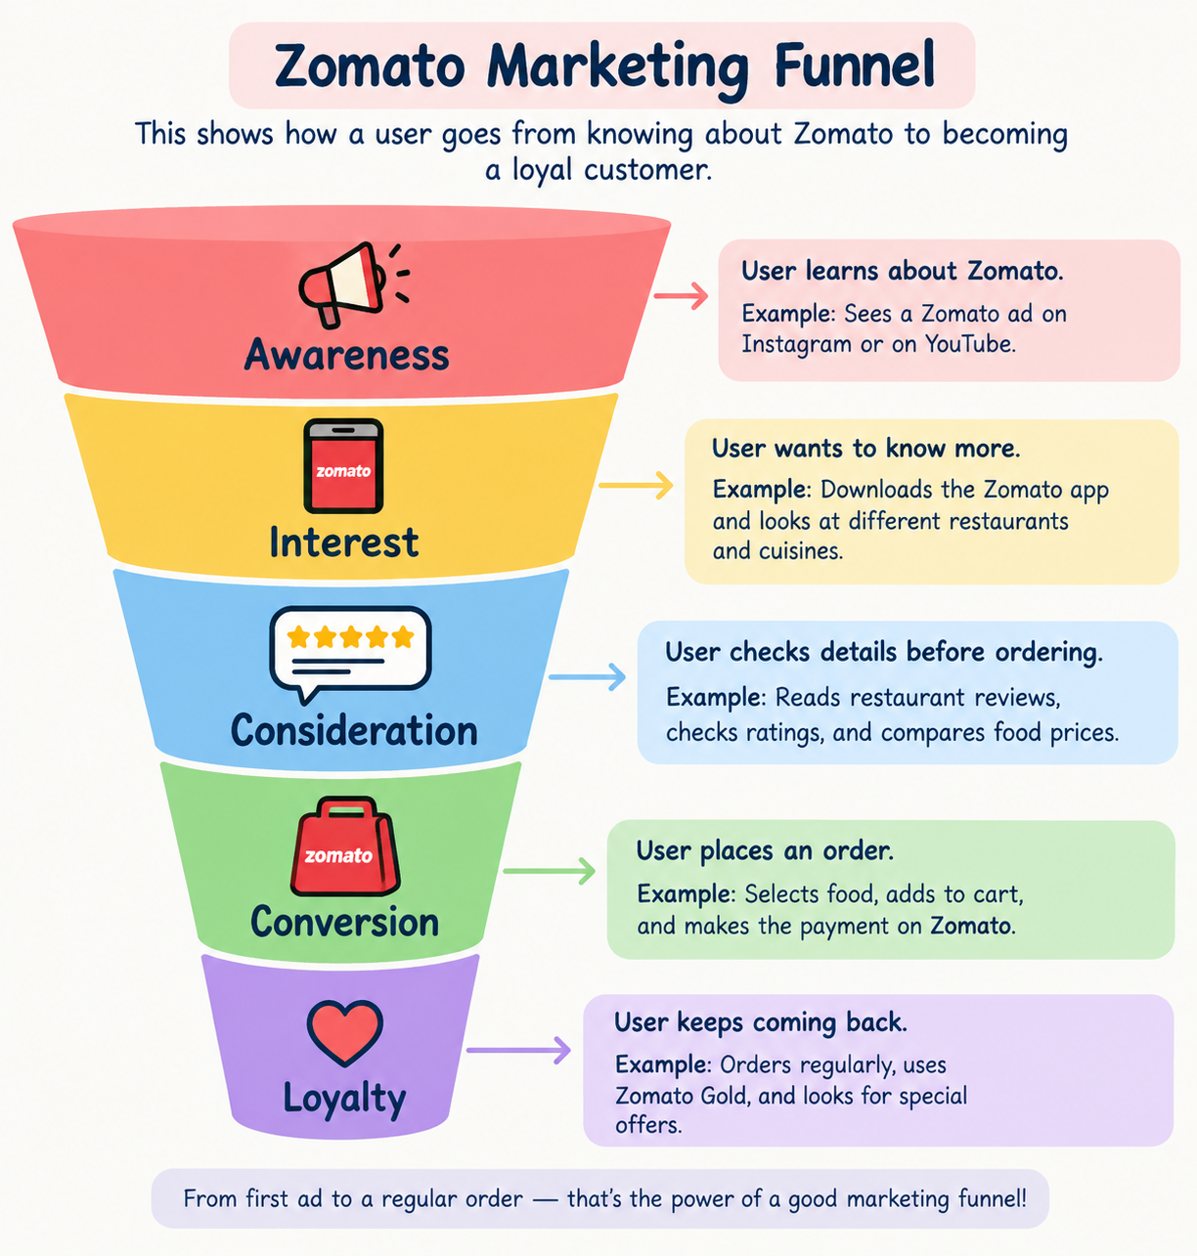

- Create a table showing at least 3 key metrics for each stage of the marketing funnel for Flipkart (e.g., Impressions, Click-Through Rate, Add to Cart, Purchases, Repeat Orders).

Funnel Stage | 3 Key Metrics | What It Measures
Awareness | Impressions, Reach, Ad Views | How many people see Flipkart ads
Interest | Clicks, Click-Through Rate (CTR), App Visits | How many people show interest
Consideration | Product Views, Add to Cart, Wishlist | How many people think about buying
Conversion | Purchases, Conversion Rate, Payment Success | How many people complete a purchase
Loyalty | Repeat Orders, Customer,Retention, Reviews/Ratings | How many customers return and buy again

- Given these sample numbers for a food delivery campaign: 10,000 people saw the ad, 1,200 clicked, 300 installed the app, and 60 placed an order. Calculate the conversion rate between each stage and overall.<br><br><em><strong>Hint:</strong> Conversion rate = (Next stage / Previous stage) x 100%</em>

Conversion Rate Calculation
Formula: Conversion Rate = (Next Stage ÷ Previous Stage) × 100
Stage | Numbers | Conversion Rate
Ad Views → Clicks | 1,200 ÷ 10,000 | 12%
Clicks → App Installs | 300 ÷ 1,200 | 25%
App Installs → Orders | 60 ÷ 300 | 20%
Overall: Ad Views → Orders | 60 ÷ 10,000 | 0.6%

- 12% of people who saw the ad clicked it.
- 25% of people who clicked installed the app.
- 20% of people who installed placed an order.
- Overall conversion rate = 0.6%.
- Pick any one metric from your previous table (e.g., Click-Through Rate or Repeat Purchase Ratio). Explain in 2-3 lines how a digital marketer could use this metric to improve their campaign for a music streaming app like Spotify.

Metric: Click-Through Rate (CTR)
CTR shows how many people click on a Spotify ad after seeing it. If CTR is low, the marketer can change the ad design, offer, or message to make it more attractive and get more clicks.

